**Past Modals of Deduction: The Hangover (Speaking)**

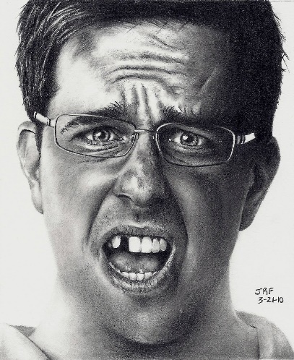**Introduction**

1. What is a hangover?
2. Do you get hangovers?
3. When was the last time you had one?
4. Do any specific drinks give you a worse hangover?
5. **Work in pairs. Read out the following situation.**

*You wake up on your sofa with a very sore head. Your friends are all sleeping on the floor of the living room. One of your friends is wearing a wedding dress. You have a big bruise on your knee. There is an unfamiliar cat walking around the room. The room smells of vomit. Your car is not outside.*

*What happened last night???*

1. **First brainstorm the questions for the mysteries:**
2. *Where did we leave the car?*

*Bar stolen*

1. *Where did the cat come from?*

*Take it from street*

1. *Why is your friend wearing a wedding dress?*

*Steal it form wedding dress market*

1. *Why did I fall asleep on the sofa?*

*Put you there*

1. *Why does my head hurt?*

*Drink to much*

1. *How did I hurt my knee?*

*Fall down some steers*

1. *Why does the house smell like vomit?*

*Drink to much*

1. **Now orally express your thoughts (still in groups) with phrases like these:**

|  |  |  |
| --- | --- | --- |
| Possible past actions | Could/might/may have + past part. | *My friend might…* |
| Almost certain past actions | Must have + past part. | *We must …* |
| Impossible past actions | Can’t have + past part. | *We can’t …* |
| Expressing regret | Should/shouldn’t have + past part. | *We shouldn’t…* |

**THE HANGOVER - FILM**

[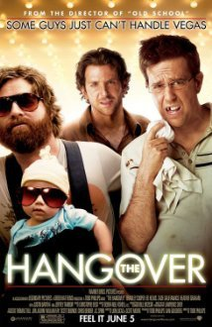](https://freeenglishlessonplans.files.wordpress.com/2014/04/hangover.jpg)

**TASK:** You are going to watch a clip from the film “The Hangover” that contains a similar situation. While you watch, make notes of the different mysteries. What could have happened? Use past modals of deduction!

<https://www.youtube.com/watch?v=xlrqaAjBwS4> (ca. 5 minutes)

Where come the animals from

How did he lose his tooth?

__________________________________________________________________________

__________________________________________________________________________

__________________________________________________________________________

__________________________________________________________________________

__________________________________________________________________________

__________________________________________________________________________

__________________________________________________________________________

__________________________________________________________________________

__________________________________________________________________________

__________________________________________________________________________

__________________________________________________________________________

__________________________________________________________________________

__________________________________________________________________________

__________________________________________________________________________

__________________________________________________________________________

__________________________________________________________________________

**Possible sentences (page 1):**

|  |  |  |
| --- | --- | --- |
| Possible past actions | Could/might/may have + past part. | My friend **might have got** married! |
| Almost certain past actions | Must have + past part. | We **must have got** really drunk. |
| Impossible past actions | Can’t have + past part. | I **can’t have driven** home. |
| Expressing regret | Should/shouldn’t have + past part. | We **shouldn’t have drunk** so much. |